# k8s部署Prometheus

## 1. 部署

创建命名空间：

[root@master ~]# kubectl create ns prom   
namespace/prom created

将 prometheus.yml 文件用 ConfigMap 的形式进行管理：（prometheus-cm.yaml）

apiVersion: v1  
kind: ConfigMap  
metadata:  
 name: prometheus-config  
 namespace: prom  
data:  
 prometheus.yml: |  
 global:  
 scrape_interval: 15s  
 scrape_timeout: 15s  
 scrape_configs:  
 - job_name: 'prometheus'  
 static_configs:  
 - targets: ['localhost:9090']

[root@master prom]# kubectl apply -f prometheus-cm.yaml  
configmap/prometheus-config created

以后如果我们有新的资源需要被监控，我们只需要将上面的 ConfigMap 对象更新即可。

创建 prometheus 的 Pod 资源：(prometheus-deploy.yaml)

apiVersion: apps/v1  
kind: Deployment  
metadata:  
 name: prometheus  
 namespace: prom  
 labels:  
 app: prometheus  
spec:  
 selector:  
 matchLabels:  
 app: prometheus  
 template:  
 metadata:  
 labels:  
 app: prometheus  
 spec:  
 serviceAccountName: prometheus  
 nodeSelector:  
 monitor: prometheus  
 containers:  
 - image: prom/prometheus:v2.37.1  
 name: prometheus  
 args:  
 - "--config.file=/etc/prometheus/prometheus.yml"  
 - "--storage.tsdb.path=/prometheus" # 指定tsdb数据路径,Prometheus的本地存储为Promethazine TSDB  
 - "--storage.tsdb.retention.time=24h"  
 - "--web.enable-admin-api" # 控制对admin HTTP API的访问，其中包括删除时间序列等功能  
 - "--web.enable-lifecycle" # 支持热更新，直接执行localhost:9090/-/reload立即生效  
 - "--web.console.libraries=/usr/share/prometheus/console_libraries"  
 - "--web.console.templates=/usr/share/prometheus/consoles"  
 ports:  
 - containerPort: 9090  
 name: http  
 volumeMounts:  
 - mountPath: "/etc/prometheus"  
 name: config-volume  
 - mountPath: "/prometheus"  
 name: data  
 resources:  
 requests:  
 cpu: 100m  
 memory: 512Mi  
 limits:  
 cpu: 100m  
 memory: 512Mi  
 securityContext:  
 runAsUser: 0 # root用户权限  
 volumes:  
 - name: data  
 hostPath:  
 path: /data/prometheus/  
 - configMap:  
 name: prometheus-config  
 name: config-volume

通过 --storage.tsdb.path=/prometheus 指定数据目录，然后将该目录声明挂载到 /data/prometheus 这个主机目录下面。

使用 nodeSelector 将 Pod 固定到了一个具有 monitor=prometheus 标签的节点上，所以需要为目标节点打上这个标签：

[root@master prom]# kubectl label node node2 monitor=prometheus  
node/node2 labeled

prometheus 可以访问 Kubernetes 的一些资源对象，所以需要配置 rbac 相关认证，这里我们使用了一个名为 prometheus 的 serviceAccount 对象：(prometheus-rbac.yaml)

apiVersion: v1  
kind: ServiceAccount  
metadata:  
 name: prometheus  
 namespace: prom  
---  
apiVersion: rbac.authorization.k8s.io/v1  
kind: ClusterRole  
metadata:  
 name: prometheus  
rules:  
- apiGroups:  
 - ""  
 resources:  
 - nodes  
 - services  
 - endpoints  
 - pods  
 - nodes/proxy  
 verbs:  
 - get  
 - list  
 - watch  
- apiGroups:  
 - "extensions"  
 resources:  
 - ingresses  
 verbs:  
 - get  
 - list  
 - watch  
- apiGroups:  
 - ""  
 resources:  
 - configmaps  
 - nodes/metrics  
 verbs:  
 - get  
- nonResourceURLs:  
 - /metrics  
 verbs:  
 - get  
---  
apiVersion: rbac.authorization.k8s.io/v1  
kind: ClusterRoleBinding  
metadata:  
 name: prometheus  
roleRef:  
 apiGroup: rbac.authorization.k8s.io  
 kind: ClusterRole  
 name: prometheus  
subjects:  
- kind: ServiceAccount  
 name: prometheus  
 namespace: prom

权限规则声明中有一个 nonResourceURLs 的属性，是用来对非资源型 metrics 进行操作的权限声明。

[root@master prom]# kubectl apply -f prometheus-rbac.yaml   
serviceaccount/prometheus created  
clusterrole.rbac.authorization.k8s.io/prometheus created  
clusterrolebinding.rbac.authorization.k8s.io/prometheus created  
[root@master prom]# kubectl apply -f prometheus-deploy.yaml   
deployment.apps/prometheus created

[root@master prom]# kubectl get pods -n prom -o wide  
NAME READY STATUS RESTARTS AGE IP NODE NOMINATED NODE READINESS GATES  
prometheus-cfc6c98f-dshdt 1/1 Running 0 33s 10.244.104.61 node2 <none> <none>

创建service，以便外部访问：

prometheus-svc.yaml

apiVersion: v1  
kind: Service  
metadata:  
 name: prometheus  
 namespace: prom  
 labels:  
 app: prometheus  
spec:  
 selector:  
 app: prometheus  
 type: NodePort  
 ports:  
 - name: web  
 port: 9090  
 targetPort: http

[root@master prom]# kubectl apply -f prometheus-svc.yaml  
service/prometheus created  
[root@master prom]# kubectl get svc -n prom  
NAME TYPE CLUSTER-IP EXTERNAL-IP PORT(S) AGE  
prometheus NodePort 10.98.38.77 <none> 9090:32197/TCP 24s

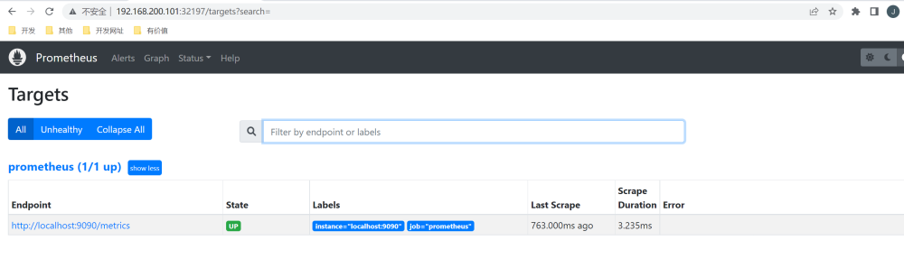

[MISSING IMAGE: , ]隔一会， 可以去Graph 菜单下面查看我们抓取的 prometheus 本身的一些监控数据

比如我们这里就选择 scrape_duration_seconds 这个指标，然后点击 Execute，就可以看到类似于下面的图表数据了：

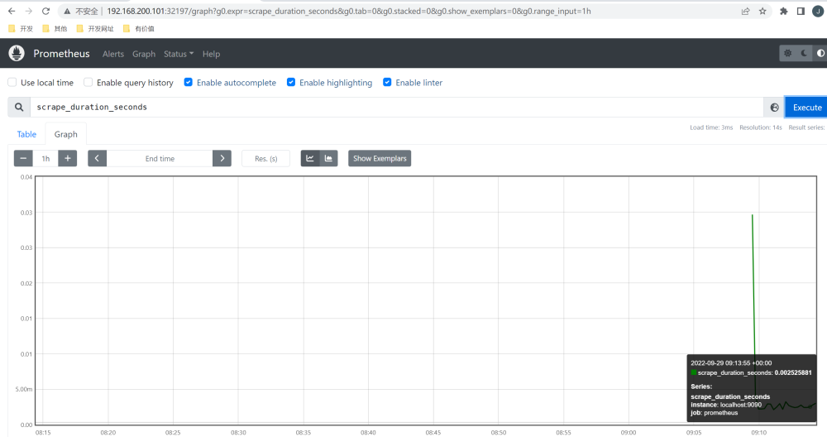

[MISSING IMAGE: , ]

## 2. 应用监控

对于普通的HTTP服务，我们只需要暴露 /metrics接口给Prometheus即可，Prometheus会定期拉取数据。

对于没有/metrics接口的，可以使用exporter来获取监控数据，exporter就是运行在被监控目标的机器上，收集监控目标的指标数据，提供给Prometheus。

Kubernetes 的各个组件都直接提供了数据指标接口/metrics。

### 2.1 coreDNS监控

对/metrics的示例，我们使用k8s中的coreDNS来说明。

coreDNS就默认开启了 /metrics 接口：

[root@master ~]# kubectl get pods -n kube-system -o wide  
NAME READY STATUS RESTARTS AGE IP NODE NOMINATED NODE READINESS GATES  
coredns-74586cf9b6-7wj84 1/1 Running 5 (110m ago) 4d18h 10.244.166.185 node1 <none> <none>  
coredns-74586cf9b6-m968n 1/1 Running 5 (110m ago) 4d18h 10.244.104.59 node2 <none> <none>

[root@master ~]# kubectl get cm coredns -n kube-system -o yaml  
apiVersion: v1  
data:  
 Corefile: |  
 .:53 {  
 errors  
 health {  
 lameduck 5s  
 }  
 ready  
 kubernetes cluster.local in-addr.arpa ip6.arpa {  
 pods insecure  
 fallthrough in-addr.arpa ip6.arpa  
 ttl 30  
 }  
 prometheus :9153  
 forward . /etc/resolv.conf {  
 max_concurrent 1000  
 }  
 cache 30  
 loop  
 reload  
 loadbalance  
 }  
kind: ConfigMap  
metadata:  
 creationTimestamp: "2022-09-23T03:57:42Z"  
 name: coredns  
 namespace: kube-system  
 resourceVersion: "222"  
 uid: d9e139d3-872f-4d14-a504-bad88bb2840b

ConfigMap 中 prometheus :9153 就是开启 prometheus 的插件。

访问一下metrics接口

[root@master ~]# curl http://10.244.104.59:9153/metrics  
# HELP coredns_build_info A metric with a constant '1' value labeled by version, revision, and goversion from which CoreDNS was built.  
# TYPE coredns_build_info gauge  
coredns_build_info{goversion="go1.17.1",revision="13a9191",version="1.8.6"} 1  
# HELP coredns_cache_entries The number of elements in the cache.  
# TYPE coredns_cache_entries gauge  
coredns_cache_entries{server="dns://:53",type="denial"} 1  
coredns_cache_entries{server="dns://:53",type="success"} 0  
# HELP coredns_cache_hits_total The count of cache hits.  
# TYPE coredns_cache_hits_total counter  
coredns_cache_hits_total{server="dns://:53",type="denial"} 1  
# HELP coredns_cache_misses_total The count of cache misses. Deprecated, derive misses from cache hits/requests counters.  
# TYPE coredns_cache_misses_total counter  
coredns_cache_misses_total{server="dns://:53"} 3  
# HELP coredns_cache_requests_total The count of cache requests.  
# TYPE coredns_cache_requests_total counter  
coredns_cache_requests_total{server="dns://:53"} 4  
# HELP coredns_dns_request_duration_seconds Histogram of the time (in seconds) each request took per zone.  
# TYPE coredns_dns_request_duration_seconds histogram  
coredns_dns_request_duration_seconds_bucket{server="dns://:53",zone=".",le="0.00025"} 1

我们可以将这个 /metrics 接口配置到 prometheus.yml 中去了：

apiVersion: v1  
kind: ConfigMap  
metadata:  
 name: prometheus-config  
 namespace: prom  
data:  
 prometheus.yml: |  
 global:  
 scrape_interval: 15s  
 scrape_timeout: 15s  
  
 scrape_configs:  
 - job_name: 'prometheus'  
 static_configs:  
 - targets: ['localhost:9090']  
 - job_name: 'coredns'  
 static_configs:  
 - targets: ['10.244.166.185:9153', '10.244.104.59:9153']

更新：

[root@master prom]# kubectl apply -f prometheus-cm.yaml  
configmap/prometheus-config configured

由于 ConfigMap 通过 Volume 的形式挂载到 Pod 中去的热更新需要一定的间隔时间才会生效，所以需要稍微等一小会儿。

之前我们加了--web.enable-lifecycle，用reload重新载入，就可以看到新的内容。

[root@master prom]# kubectl get service -n prom  
NAME TYPE CLUSTER-IP EXTERNAL-IP PORT(S) AGE  
prometheus NodePort 10.98.38.77 <none> 9090:32197/TCP 19h  
[root@master prom]# curl -X POST "http://10.98.38.77:9090/-/reload"

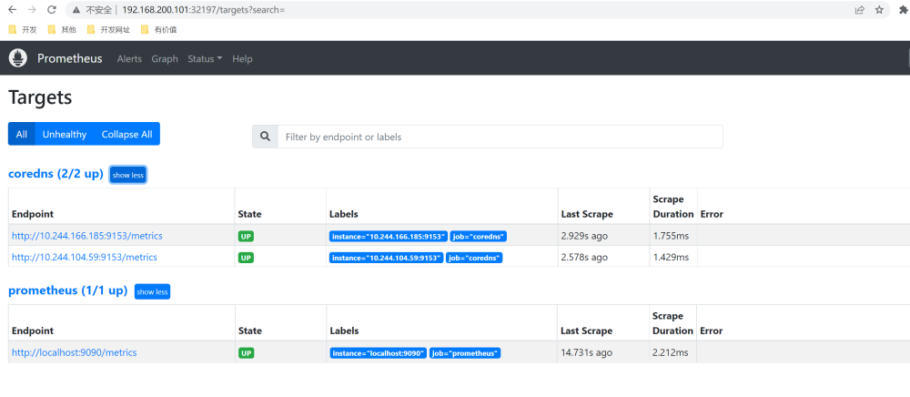

[MISSING IMAGE: , ]

### 2.2 exporter

我们通过一个 [redis-exporter](https://github.com/oliver006/redis_exporter) 的服务来监控 redis 服务。

部署一个 redis 应用，并用 redis-exporter 的方式来采集监控数据供 Prometheus 使用，如下资源清单文件：（prome-redis.yaml）

apiVersion: apps/v1  
kind: Deployment  
metadata:  
 name: redis  
 namespace: prom  
spec:  
 selector:  
 matchLabels:  
 app: redis  
 template:  
 metadata:  
 annotations:  
 prometheus.io/scrape: "true"  
 prometheus.io/port: "9121"  
 labels:  
 app: redis  
 spec:  
 containers:  
 - name: redis  
 image: redis:4  
 resources:  
 requests:  
 cpu: 100m  
 memory: 100Mi  
 ports:  
 - containerPort: 6379  
 - name: redis-exporter  
 image: oliver006/redis_exporter:latest  
 resources:  
 requests:  
 cpu: 100m  
 memory: 100Mi  
 ports:  
 - containerPort: 9121  
---  
kind: Service  
apiVersion: v1  
metadata:  
 name: redis  
 namespace: prom  
spec:  
 selector:  
 app: redis  
 ports:  
 - name: redis  
 port: 6379  
 targetPort: 6379  
 - name: prom  
 port: 9121  
 targetPort: 9121

redis 这个 Pod 中包含了两个容器，一个就是 redis 本身的主应用，另外一个容器就是 redis_exporter。

[root@master prom]# kubectl apply -f prome-redis.yaml  
deployment.apps/redis created  
service/redis created

[root@master prom]# kubectl get pods -n prom  
NAME READY STATUS RESTARTS AGE  
prometheus-cfc6c98f-dshdt 1/1 Running 1 (152m ago) 20h  
redis-65c96d4bb4-fz55l 2/2 Running 0 39s  
[root@master prom]# kubectl get svc -n prom   
NAME TYPE CLUSTER-IP EXTERNAL-IP PORT(S) AGE  
prometheus NodePort 10.98.38.77 <none> 9090:32197/TCP 20h  
redis ClusterIP 10.111.11.242 <none> 6379/TCP,9121/TCP 41s

可以通过 9121 端口来校验是否能够采集到数据：

[root@master prom]# curl 10.111.11.242:9121/metrics  
# HELP go_gc_duration_seconds A summary of the pause duration of garbage collection cycles.  
# TYPE go_gc_duration_seconds summary  
go_gc_duration_seconds{quantile="0"} 0  
go_gc_duration_seconds{quantile="0.25"} 0  
go_gc_duration_seconds{quantile="0.5"} 0  
go_gc_duration_seconds{quantile="0.75"} 0  
go_gc_duration_seconds{quantile="1"} 0  
go_gc_duration_seconds_sum 0  
go_gc_duration_seconds_count 0  
# HELP go_goroutines Number of goroutines that currently exist.  
# TYPE go_goroutines gauge  
go_goroutines 6

更新 Prometheus 的配置文件：

apiVersion: v1  
kind: ConfigMap  
metadata:  
 name: prometheus-config  
 namespace: prom  
data:  
 prometheus.yml: |  
 global:  
 scrape_interval: 15s  
 scrape_timeout: 15s  
  
 scrape_configs:  
 - job_name: 'prometheus'  
 static_configs:  
 - targets: ['localhost:9090']  
  
 - job_name: 'coredns'  
 static_configs:  
 - targets: ['10.244.166.185:9153', '10.244.104.59:9153']  
 - job_name: 'redis'  
 static_configs:  
 - targets: ['redis:9121']

我们这里是通过 Service 去配置的 redis 服务。

[root@master prom]# kubectl apply -f prometheus-cm.yaml  
configmap/prometheus-config configured  
[root@master prom]# curl -X POST "http://10.98.38.77:9090/-/reload"

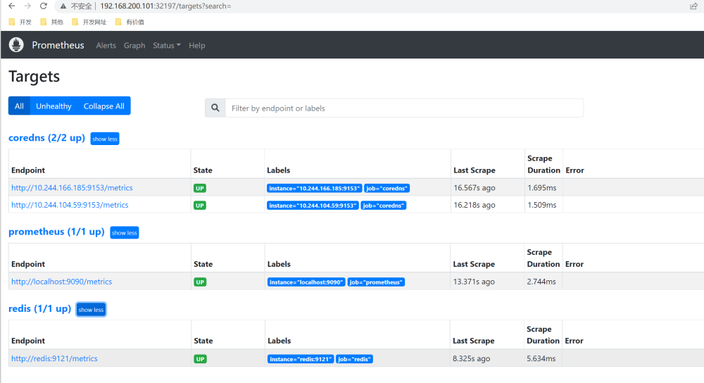

[MISSING IMAGE: , ]